Git Assignment 2

improved-octo-winner

* Created working directory and created files feature 1.txt and feature 2.txt in master branch
* Created 3 branch in command terminal
  1. Git branch develop
  2. Git branch feature1
  3. Git branch feature2
* In develop branch created devwork.txt, do not stage or commit it,
* Stash this file, and checkout to feature1 branch ● Create new.txt file in feature1 branch, stage and commit this file ● Checkout to develop, unstash this file and commit
  1. Git checkout develop
  2. Folder created devwork.txt file
  3. Git stash
  4. Git checkout feature1
  5. Inside folder created new.txt file
  6. Git add .
  7. Git commit –m “start”
  8. Git checkout develop
  9. Git stash pop
  10. Git add .
  11. Git commit –m “added”

Master branch files:-

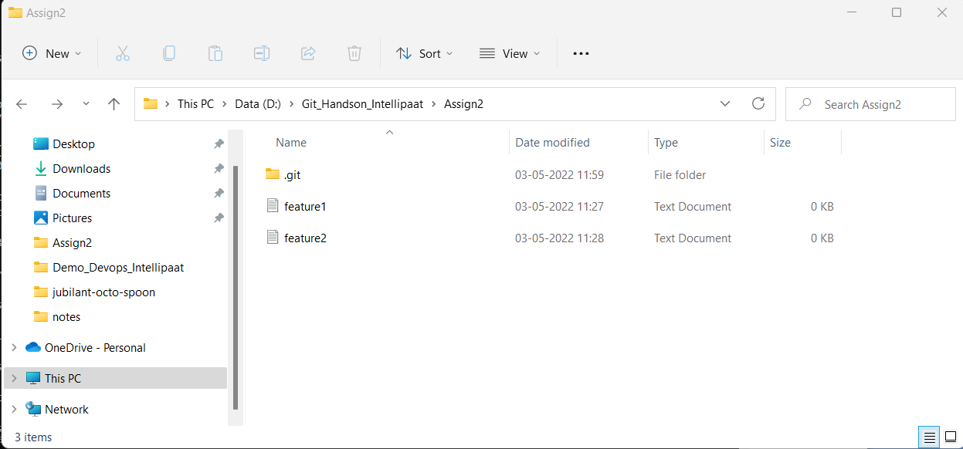

Develop branch files:-

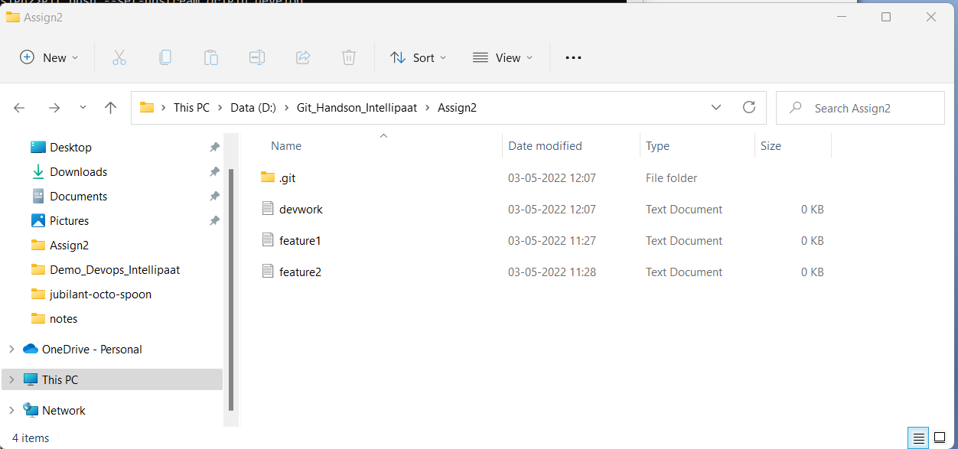

Feature1 branch files:-

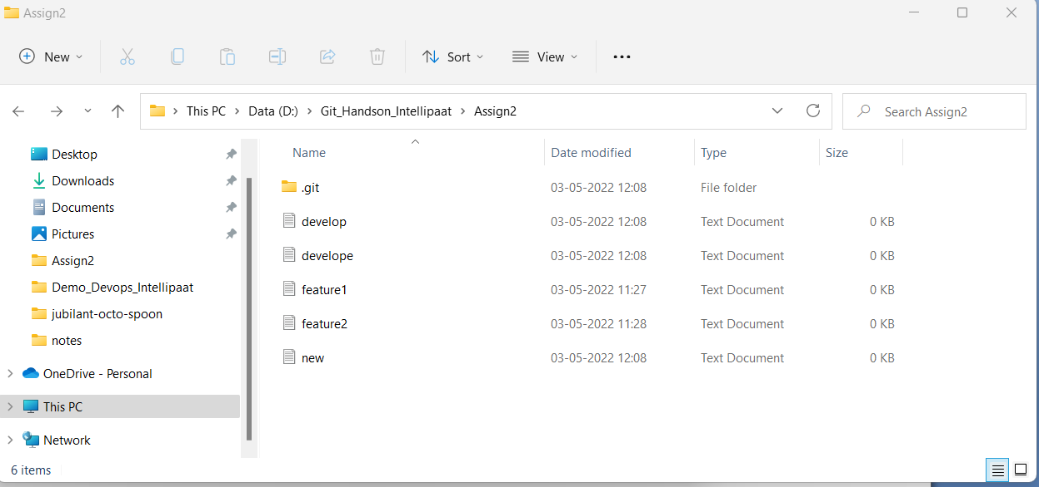

FEatire 2 branch files:-

